virtual Campus tour

By

Dhruv Pandya (22BCA144)

Tirth Patel (22BCA239)

Under Guidance

of

Internal Guide

Dr. Ankit Faldu

Submitted to

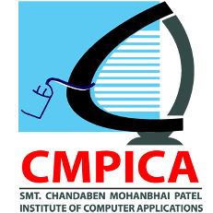

Smt. Chandaben Mohanbhai Patel Institute of Computer Applications

CHARUSAT

Changa

April 2025



[Accredited with Grade A+ by NAAC,](https://www.charusat.ac.in/)

CHAROTAR UNIVERSITY OF SCIENCE AND TECHNOLOGY

Changa

**Acknowledgement**

Knowledge in itself is a continuous process. At this moment of our substantial enhancement, we rarely find words to express our gratitude towards those who were constantly involved with us.

The completion of any inter disciplinary project depends upon coordination, cooperation and combined efforts of several resources of knowledge, creativity, skill, energy and time. The work being accomplished now, we feel our sincerest urge to recall and knowledge through these lines, trying our best to give full credit wherever it deserves.

We would like to thank our project guide and I/C Dean **Dr. Sanskruti Patel** and I/C Principal **Dr. Dharmendra Patel** who advised and gave us moral support through the duration of our project. Without their constant encouragement we could not have been able to achieve what we have.

It’s our good fortune that we had support and well wishes of many. We are thankful to all and those names which have been forgotten to acknowledge here but contributions have not gone unnoticed.

With Sincere Regards,

**Dhruv Pandya (22BCA144)**

**Tirth Patel (22BCA239)**

**Table of Contents**

|  |  |  |  |
| --- | --- | --- | --- |
| **Sr. No** |  | **Subject** | **Page Number** |
| **1** |  | **Project Profile** | **5** |
| **2** |  | **Introduction to tools** | **6** |
| **3** |  | **System Study** | **8** |
|  |  | Existing System | **9** |
|  |  | Proposed System | **9** |
|  |  | Scope of the Proposed System | **9** |
|  |  | Aim and Objective of the Proposed System | **10** |
|  |  | Feasibility Study | **10** |
|  | **5.1** | Operational Feasibility | **11** |
|  | **5.2** | Technical Feasibility | **10** |
|  | **5.3** | Economical Feasibility | **11** |
|  | **5.4** | Time Feasibility |  |
| **4** |  | **System Analysis** | **12** |
|  | **1.** | Requirements Specification (along with System Modules) | **13** |
|  | **2.** | Use Case Diagram | **13** |
|  | **3.** | Activity Diagram | **14** |
|  | **4.** | Class Diagram | **-** |
| **5** |  | **System Design** | **16** |
|  | **1.** | Data Dictionary | **-** |
|  | **2.** | Screen Layouts | **16** |
|  | **3.** | Reports | **-** |
| **6** |  | **System Testing** |  |
|  | **1.** | Testing Strategies | **30** |
|  | **2.** | Test Cases |  |
| **7** |  | **Future Enhancement** | **38** |
| **8** |  | Bibliography/References | **39** |
| **9** |  | Reporting Report (to be collected from respective internal guide) |  |

Project Profile

## Project Profile

**Project Name:** Virtual Campus Tour

**Type of Application:** 3D Interactive Application/Game

**Project Description:**

The Virtual Campus Tour is an interactive 3D application designed to provide an immersive experience of our department. Users can explore the digital model of the campus, including classrooms, labs, a staffroom, and an auditorium. The application allows free movement and teleportation to different locations through a dedicated teleport page. This project enhances engagement and provides a realistic virtual tour for students, faculty, and visitors.

##### Team Size: 2

**Front End:** Unity (C#), Blender (for 3D models)

**Back End:** Not applicable (Standalone application)

**Tools used:** Unity (C#), Blender, Visual Studio, Canva (for textures)

Introduction to tools

### 

### Blender

### Blender is an open-source 3D modeling tool used for creating and designing the campus environment including:

### Buildings and Infrastructure: Constructing classrooms, labs, staffrooms, and the auditorium in a realistic 3D format.

### Object Modeling: Designing desks, chairs, computers, whiteboards, and other elements to add detail to the environment.

### Optimization: Ensuring models are lightweight and efficient to maintain smooth performance within Unity.

### 2. Unity

### Unity is a powerful and widely used game engine that allows developers to create interactive 3D environments. In this project, Unity played a crucial role in:

### Player Movement: Implementing smooth navigation using C# scripts to allow the user to explore the virtual campus.

### Teleportation System: Creating a teleportation feature to instantly move the player to specific locations like classrooms, labs, and the staffroom.

### Door Interaction and Animations: Programming doors to open and close when a player interacts with them, adding a realistic feel to the environment.

### Scene Management: Organizing different areas of the campus efficiently to optimize performance and provide a seamless experience.

### 3.Visual Studio

### Visual Studio is the primary code editor used for writing and debugging C# scripts within Unity. It was essential for:

### Writing Player Controls: Implementing scripts that manage player movement, teleportation, and interactions.

### Handling Game Logic: Programming conditions for door animations, teleportation mechanics, and user interactions.

### Debugging & Testing: Identifying and fixing errors to ensure a smooth user experience.

### 4. Canva

### Canva is a graphic design tool used to enhance the visual quality of the Virtual Campus Tour. It played a role in:

### Texture Design: Creating realistic textures for walls, floors, and other surfaces to improve the appearance of the 3D models.

### User Interface (UI): Designing icons, buttons, and teleportation menus to make the application visually appealing and user-friendly.

* **Branding Elements:** Adding labels, signage, and other graphical components to make the virtual campus more informative and engaging.

System Study

**3.1 Existing System :**

Traditionally, campus tours are conducted in person, requiring students, faculty, and visitors to physically visit the institute. This system has several limitations:

* **Time-Consuming**: Visitors must allocate time to physically explore the campus.
* **Limited Accessibility**: Not everyone can visit due to distance or scheduling conflicts.
* **Lack of Interactivity**: Physical tours do not offer features like instant teleportation or detailed exploration at the user’s convenience.
* **Resource Intensive**: Requires staff or student volunteers to guide visitors.

**3.2 Proposed System :**

The Virtual Campus Tour application provides an interactive and immersive way to explore the campus digitally. Key improvements over the existing system include:

* **3D Interactive Experience:** Users can explore classrooms, labs, the staffroom, and the auditorium in a fully rendered 3D environment.
* **Player Movement & Teleportation:** Players can move freely or teleport to specific locations instantly using a teleport page.
* **Realistic Interactions**b The system includes door animations and interactive elements to enhance engagement.
* **Accessible Anytime, Anywhere:** Users can experience the campus tour remotely, overcoming geographical barriers.
* **No Human Guides Required:** Eliminates the need for staff or students to conduct physical tours, saving time and resources

**3.3 Scope of the Proposed System :**

The Virtual Campus Tour aims to provide an interactive and immersive way for users to explore the campus digitally. It is designed to be user-friendly, accessible, and engaging. The system’s scope includes:

* **Virtual Exploration:** Users can navigate the campus freely and teleport to specific locations such as classrooms, labs, the staffroom, and the auditorium.
* **3D Realism:** The environment is modeled in 3D using Blender, with realistic textures designed in Canva.
* **Interactive Features:** Doors are animated and interactive, allowing users to experience a dynamic environment.
* **Remote Accessibility:** The system can be accessed from anywhere, reducing the need for physical campus visits.
* **Enhanced Engagement:** The virtual tour can be used for student orientation, promotional purposes, and academic events

**3.4 Aim and Objective of the Proposed System**

**Aim:** The aim of this project is to develop a Virtual Campus Tour application that provides a 3D interactive experience for users to explore the department’s infrastructure in a realistic and engaging manner.

**Objectives:**

* **Create an Immersive Experience**: Develop a high-quality 3D campus environment with interactive elements.
* **Improve Accessibility**: Enable students, faculty, and visitors to explore the campus remotely at any time.
* **Enhance User Interaction**: Implement player movement, door animations, and teleportation for seamless navigation.
* **Optimize Performance**: Ensure the application runs smoothly with efficient 3D models and well-structured code.
* **Reduce Dependence on Physical Tours**: Provide an alternative to traditional campus visits, saving time and resources.

**3.5 Feasibility Study**

A feasibility study evaluates the viability of the proposed Virtual Campus Tour system based on different criteria:

* **Operational Feasibility:**

The system provides an easy-to-use interface for users, with intuitive movement and teleportation controls. It meets the needs of students, faculty, and visitors by offering a realistic and detailed virtual experience.No additional training is required for users, as the system is self-explanatory

* **Technical Feasibility:**

The system is developed using Unity (C#) for game development, Blender for 3D modeling, Visual Studio for scripting, and Canva for textures.

All required technologies are accessible and supported by the development team.

The project does not require a backend, making implementation straightforward.

* **Economic Feasibility:**

The project primarily uses open-source or free-to-use tools like Unity, Blender, and Canva, making it cost-effective.

No additional hardware is required beyond a standard PC for development and testing.

Reduces the need for printed brochures or physical guides, saving institutional costs.

* **Time Feasibility**

The development timeline is manageable, given the available resources and team expertise.

The project can be expanded in future iterations with additional features like VR support.

System Analysis

1. **Requirements Specification :**

The traditional campus tour process requires physical presence, making it difficult for students, faculty, and visitors to explore the campus remotely. The existing system lacks interactivity and accessibility, leading to challenges such as:

**System Modules:**

* + **Start Screen:** Interactive UI with magnifying glass cursor and hover effects.
  + **Explore Mode:** Free movement in the virtual campus.
  + **Teleport System:** Direct navigation to locations.
  + **Sound Settings:** Background music and footstep control.
  + **Exit System:** Proper program termination.

1. **Use Case Diagram**

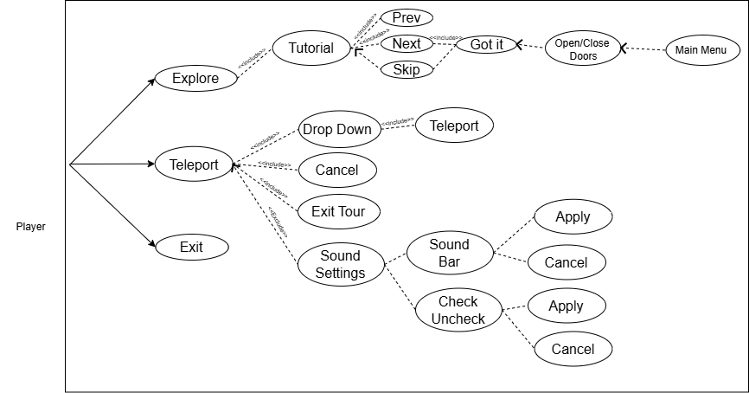

1. **Activity Diagram**

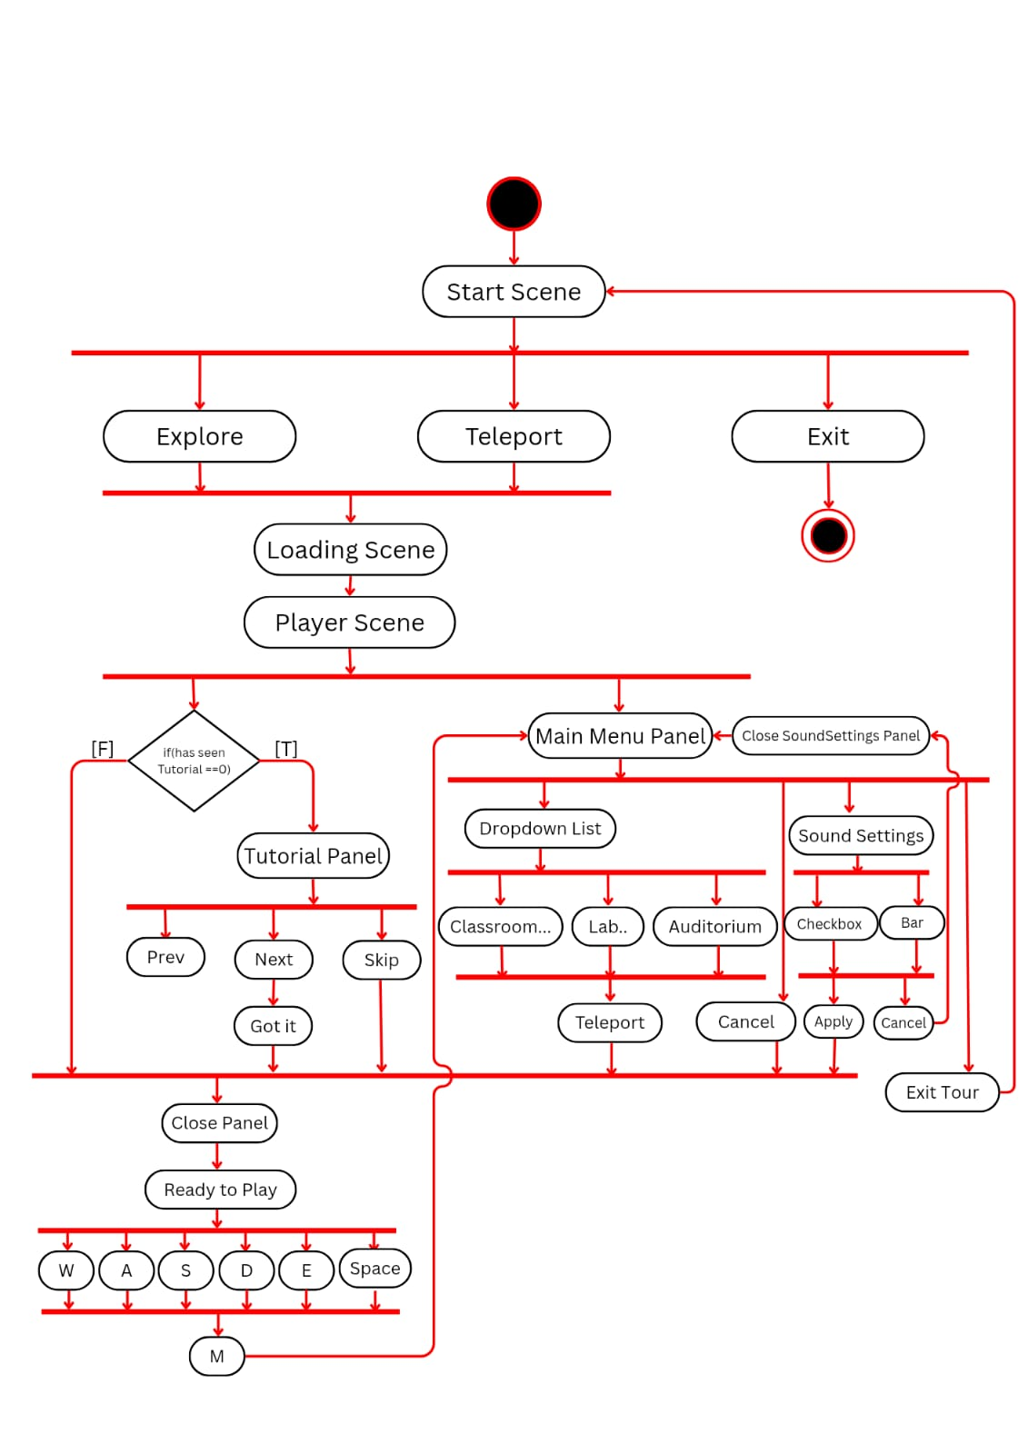

System Design

## Start Scene:

## 

## Description :

## The three dots act as a menu toggle, and when hovered over, they reveal three options:

* + - * **Explore** – Starts or continues the virtual tour.
      * **Teleport** – Allows quick navigation to different locations.
      * **Exit** – Closes the tour or returns to the main menu.

## Loading Scene

## 

## Description :

## This is a loading screen which has a slider bar to show the load progress of PlayerScene.

## 

## 

## 

## Tutorial Scene-1

## 

## Description :

## This is a tutorial screen that instructs players on how to move forward using the "W" key or the Up Arrow key. It features navigation buttons for "PREV," "NEXT," and "SKIP," where the "PREV" button is disabled and not clickable.

## Tutorial Scene-2

## 

## Description :

## This is a tutorial screen that instructs players to press the "Space" key to jump. It features navigation buttons for "PREV," "NEXT," and "SKIP," where the "PREV" button is now clickable, allowing users to go back to the previous tutorial step.

## Tutorial Scene-3

## 

## 

## Description :

## This is a tutorial screen that instructs players to press the "M" key to open the menu. The screen features navigation buttons, where the "PREV" button is clickable, the "NEXT" button is disabled, and a "GOT IT!" button is available to confirm and exit the tutorial.

## Spawn Point (Main Gate)

## 

## Description :

## This is View from Main Gate Area of Campus and it is the Spawn point of Player

## Player Scene

## 

## Description :

## This is an in-game view of your college tour project in Unity URP 3D. The camera is positioned at the bottom of a staircase, leading to the first floor of the campus. The signage above the stairs provides directions to various locations like classrooms, labs, offices, and washrooms. The "MENU" button is visible at the top left corner, indicating an interactive UI element.

## Lab

## 

## Description :

## This is View from Lab Area of Campus

## 9 .Auditorium

## 

## Description :

## This is View from Auditorium Area of Campus

## Classroom

## 

## Description :

## This is View from ClassRoom Area of Campus

## Teleport Menu-1

## 

## Description :

## This screen allows users to instantly travel to key locations in the 3D Virtual Campus Tour. Users can select a destination, such as "Main Entry," and teleport with a single click. The interface includes options to Teleport, Cancel, Exit Tour, and Adjust Sound Settings. The space-themed background enhances immersion, making navigation quick and engaging.

## Teleport Menu-2

## 

## Description :

## This teleportation menu in the 3D Virtual Campus Tour allows users to instantly navigate between key locations such as Main Entry, Classrooms, and Labs. The dropdown list provides multiple destination choices, enhancing accessibility. The Teleport, Cancel, and Exit Tour buttons ensure smooth user control, while the Sound Setting option customizes the experience. The futuristic wormhole background adds an immersive feel.

## Sound Settings-1

## 

## Description :

## This sound settings menu allows users to control audio levels in the 3D Virtual Campus Tour. It features adjustable sliders for Background Music and Footstep Sounds, with checkboxes to enable or disable them. The Apply and Cancel buttons let users confirm or revert changes, ensuring a customizable experience. The wooden texture background enhances visual appeal

System Testing

## System Testing :

## System testing is a crucial phase where the entire Virtual Campus Tour application is tested to ensure it meets the functional and non-functional requirements. Various testing strategies are implemented to validate individual components, integration, functionality, and overall system behavior.

## Unit Testing

## Objective: To test individual components or modules to ensure they work as expected.

## Scope: Each function, class, or module of the system is tested separately before integration.

## Bugs are identified at an early stage, reducing debugging time later.

## 

## Examples:

## Player Movement:

## Test if the player can move forward, backward, left, and right smoothly without glitches.

## Ensure movement speed remains consistent across different environments.

## Door Interaction (Pressing "E"):

## Verify that doors open and close correctly upon pressing "E".

## Ensure that doors remain interactive even after teleporting.

## Teleportation Feature:

## Check if the teleport button moves the player to the correct selected location.

## Ensure teleportation doesn’t cause unexpected lag or graphical errors.

## Sound Settings:

## Test whether enabling/disabling footsteps and background music works correctly.

## Verify that volume adjustments apply correctly when the "Apply" button is clicked.

## Integration Testing

## Objective: To ensure that different modules and components interact correctly when combined.

## Scope:

## Focuses on data flow between modules.

## Ensures features function properly when combined.

## Examples:

## Teleportation + Sound Settings

## Ensure that sound settings persist even after teleporting to another location.

## Explore Mode + Doors Interaction

## Test if doors remain interactable when the player switches from Teleport Mode back to Explore Mode.

## Start Screen → Exploration → Teleportation

## Check if transitioning between these modes functions smoothly.

## Ensure no game-breaking bugs occur when switching between them.

## Exit Tour Button

## Verify that clicking "Exit Tour" correctly returns the player to the Start Screen without glitches.

## Functional Testing

## Objective: To validate that the application performs according to specified requirements.

## Scope: Tests are based on the Virtual Campus Tour’s functional requirements.

## Ensures all features work as expected.

## Examples:

## Teleportation Accuracy:

## Verify that selecting a location from the dropdown list correctly teleports the player to that location.

## Tutorial Skipping:

## Ensure the "Got-it" button allows players to skip the tutorial.

## Start Screen Hover Effects:

## Check that hovering over Explore, Teleport, and Exit changes the dot colors and displays labels.

## Exit Button Functionality:

## Ensure clicking "Exit" on the start screen completely stops the program.

## System Testing

## Objective:

## To test the entire system as a whole, ensuring all components work together seamlessly.

## Scope:

## Verifies the complete end-to-end flow of the application.

## Ensures the system meets all performance and usability requirements.

## Examples:

## Complete User Journey Test:

## Start at Start Screen → Select Explore Mode → Interact with Doors → Open Teleport Menu (M key) → Adjust Sound Settings → Teleport to a Location → Exit Tour → Restart the Tour.

## Performance Testing:

## Ensure smooth frame rates and no major lag spikes during gameplay.

## Error Handling:

## If an invalid teleport destination is selected, the system should display an error message instead of crashing.

## 

## Regression Testing

## Objective:

## To ensure that new changes (bug fixes, optimizations) do not introduce new issues.

## Scope:

## Run previously successful test cases again after making updates.

## Examples:

## Teleportation Bug Fixes:

## If a teleportation glitch is fixed, re-test door interactions, movement, and sound

## settings to ensure they are not affected.

## Sound Setting Adjustments:

## If sound settings are modified, verify that all volume controls still work properly.

## Exploration Mode Changes:

## If movement speed is adjusted, test again to confirm doors and teleportation still function correctly.

## TEST CASES:

1. **Player Movement**

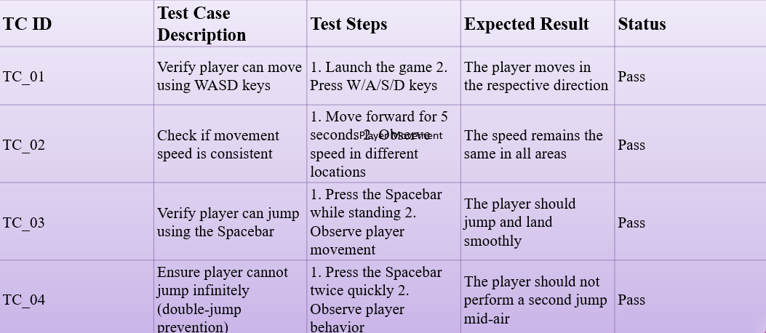

1. **Door Interaction**

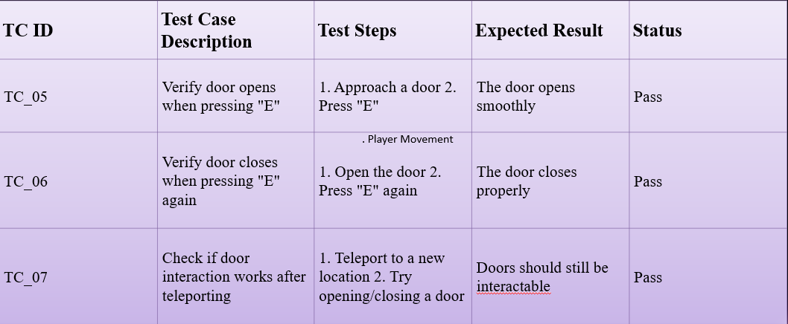

**3. Teleportation Functionality**

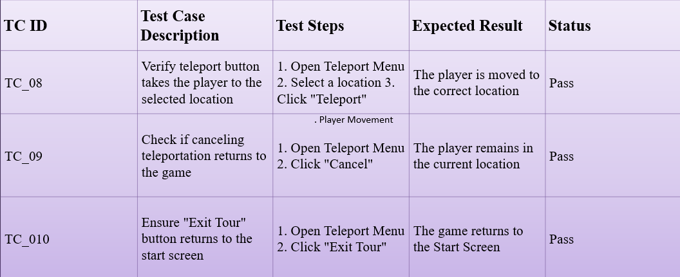

1. **Sound Settings**

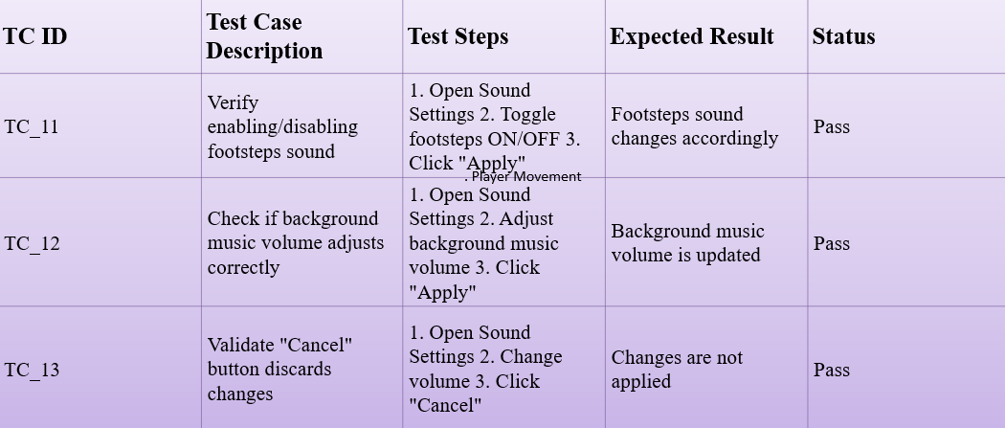

**4.General Functional Testing**

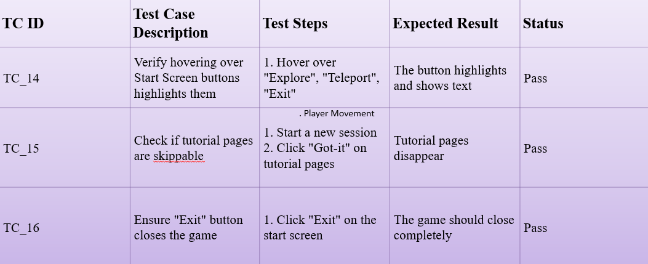

Future enhancement

* **Texture Improvement:**

Improving textures by replacing old texture with higher quality textures

* **Upgrade User Interface**:

Improving UI Elements like Dropdown Menu, Buttons, Background Images,etc.

* **Adding Features**:

Adding Features like Getting Achivements by just exploring the areas, and adding some hidden achivements for adding more Chaos.

* **Adding More Models:**

Adding More Models like Fan, AC, More Detailed Labels.

* **Adding More Interactions:**

Adding More user interactions like On & Off the AC.

* **Bug Fixing:**

Fixing all type of bugs occuring on system.

bibliography/

references

* W3School
* <https://www.w3schools.com/>
* (For Understanding C# Components Deeply)
* YouTube Tutorials
  + https://[youtu.be/4haAdmHqGOw?si=NuC3MPIyZNsll0Lk](https://youtu.be/4haAdmHqGOw?si=NuC3MPIyZNsll0Lk)
  + (For understanding modeling in blender)
  + https://[youtube.com/playlist?list=PLA-xaldQ72rwccxt4VR4sbM6Amq0hz62X&si=flALuJUv2RMUYpWq](https://youtube.com/playlist?list=PLA-xaldQ72rwccxt4VR4sbM6Amq0hz62X&si=flALuJUv2RMUYpWq)
  + (For Understanding Player Moment, Camera Control, Door Animation)
  + https://[youtu.be/NtTGq2tomqI?si=MXKNhg088FPit7-6](https://youtu.be/NtTGq2tomqI?si=MXKNhg088FPit7-6)
  + (For understanding & Developing Bench objects)
* Canva – Graphic and UI Design Resources
  + <https://www.canva.com/>  
    (Used for designing textures and UI assets for a polished interface)
* Free3D & Unity Asset Store
  + <https://www.free3d.com/>  
    https://assetstore.unity.com/  
    (Used to explore and integrate 3D models and environmental props)